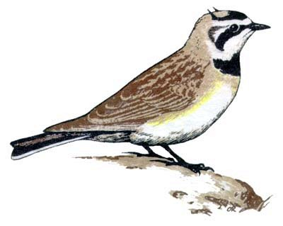
Official Nomination Form
2025 Kansas Ornithological Society
Avian Conservationist of the Year

The Kansas Ornithological Society's Avian Conservationist of the Year Award is given to an individual for making significant contributions to bird conservation and/or education. Nominations should be made for outstanding work in bird conservation, through the management or preservation of habitats, education or research. A nominee may be any professional, volunteer, educator or other person that has accomplished significant contributions in any of the areas listed. The nominee does not have to be a member of KOS, but the nominator must be a current member of KOS. The accomplishment should reflect a long-time commitment to bird conservation, research and/or education within the State of Kansas. This award will be presented during the fall annual meeting. More information can be found at: https://www.ksbirds.org/kos/AvianConservationist.html

NOMINATIONS WILL BE ACCEPTED UNTIL AUGUST 1ST.

Nomination Form

To make a nomination, send this form with attachments to:
Bob Gress, 1409 W 35th N, Wichita KS, 67204 or to bobgress@cox.net

Name of Nominee: ___________________________________________________________________

Address: ___________________________________________________________________________

Phone: _____________________________________________________________________________

E-mail: _____________________________________________________________________________

Nominator's Name: __________________________________________________________________

Address: ___________________________________________________________________________

Phone: _____________________________________________________________________________

E-mail: _____________________________________________________________________________

**Attach a typewritten description of no more then two pages, both sides of paper may be used, giving a detailed account of specific work the nominee has accomplished. Past and current achievements, organization membership or any other information the nominator feels pertinent will be considered.

